HANDS-ON 8 HTTP Client — API Integration, Observables & Interceptors
Project Structure:
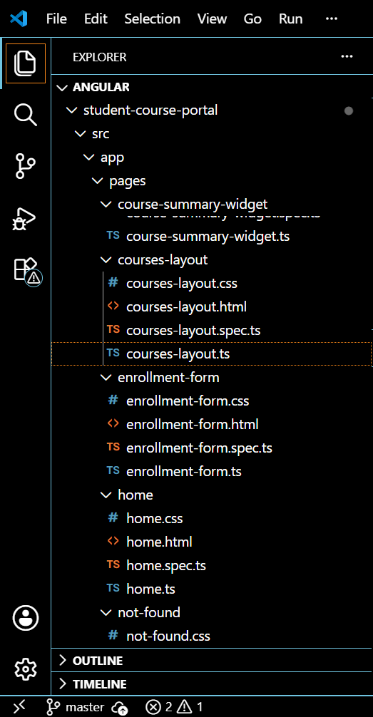
App.routes.ts:
import { Routes } from '@angular/router';

import { Home } from './pages/home/home';
import { CoursesLayout } from './pages/courses-layout/courses-layout';
import { CourseList } from './pages/course-list/course-list';
import { CourseDetail } from './pages/course-detail/course-detail';
import { StudentProfile } from './pages/student-profile/student-profile';
import { ReactiveEnrollmentForm } from './pages/reactive-enrollment-form/reactive-enrollment-form';

export const routes: Routes = [
{
path: 'courses',
component: CoursesLayout,
children: [
{
path: '',
component: CourseList
},
{
path: ':id',
component: CourseDetail
}
]
},

{
path: 'enroll',
loadChildren: () =>
import('./enrollment.routes').then(
(m) => m.ENROLLMENT_ROUTES
)
},

{
path: 'enroll-reactive',
component: ReactiveEnrollmentForm
},

{
path: 'profile',
component: StudentProfile
},

{
path: '',
component: Home
},

{
path: '**',
redirectTo: ''
}
];
Course-layout.ts
import { Component } from '@angular/core';
import { RouterModule } from '@angular/router';

@Component({
selector: 'app-courses-layout',
standalone: true,
imports: [RouterModule],
templateUrl: './courses-layout.html',
styleUrl: './courses-layout.css'
})
export class CoursesLayout {}

OUTPUT:
